**Permits Checklist**

This button on the identify parcel window is enabled when the user selects the Building department in GIS

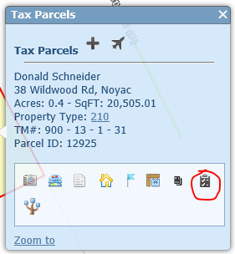

This panel is viewable when there is a permit that is still open

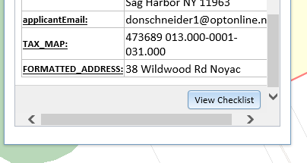

The circled buttons are enabled when the user is logged in.

Clicking ‘Save’ enters values to a database so that other users from the department can view the status of the checklist without the ability to save changes. There is an ‘Other’ category at the bottom of the list so that the inspector can enter custom requirements.

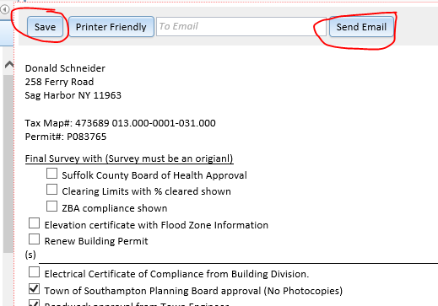

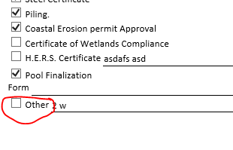

Clicking the ‘Printer Friendly’ button creates a printable form that can be sent by regular mail.

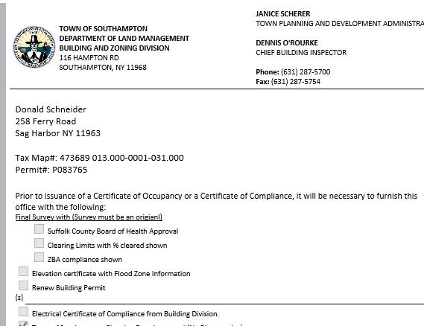

Clicking the ‘Send Email’ button requires that the ‘To Email’ box is filled out. A formatted email with the selected checklist items will be sent to the ‘To Email’ address and the inspector that is logged in.

