**Accessing Census Data via** [**https://data.census.gov/**](https://data.census.gov/)

You can access the data by following these steps for CDP, Tracts, and Block Groups:

* Visit the advanced search [https://data.census.gov/cedsci/advanced](https://urldefense.proofpoint.com/v2/url?u=https-3A__data.census.gov_cedsci_advanced&d=DwMFaQ&c=ckSw_QPOgiN5c7mkmGRjIUX5yYfoDM2_jKaJzviCxzI&r=pfIzrLyYynD_Lc_x3OVWBli6LDmsyrcrq8d6peKYQ7A&m=3Zoh1kM-VWvefp07TbQPdPYG9wF14q_FBelx_JRvu2A&s=KSN_CrCVR77SKo6SsrlFsnldL_AasZUkdw3WKLtqVNU&e=)
* Type your table IDs in the first text box directly under the advanced search heading: ex: **B01003 B25001 B25003 B25070 B25091  
    
  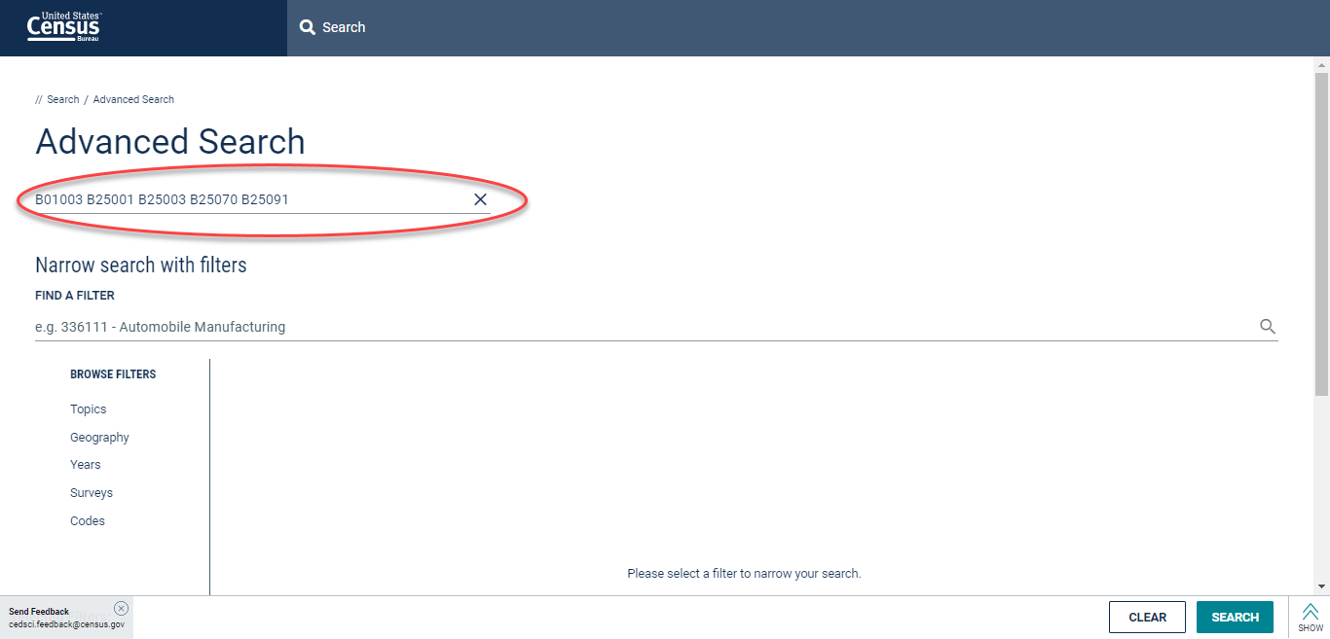**
* Select Geography>Place>New York>**Southampton Town, New York  
    
  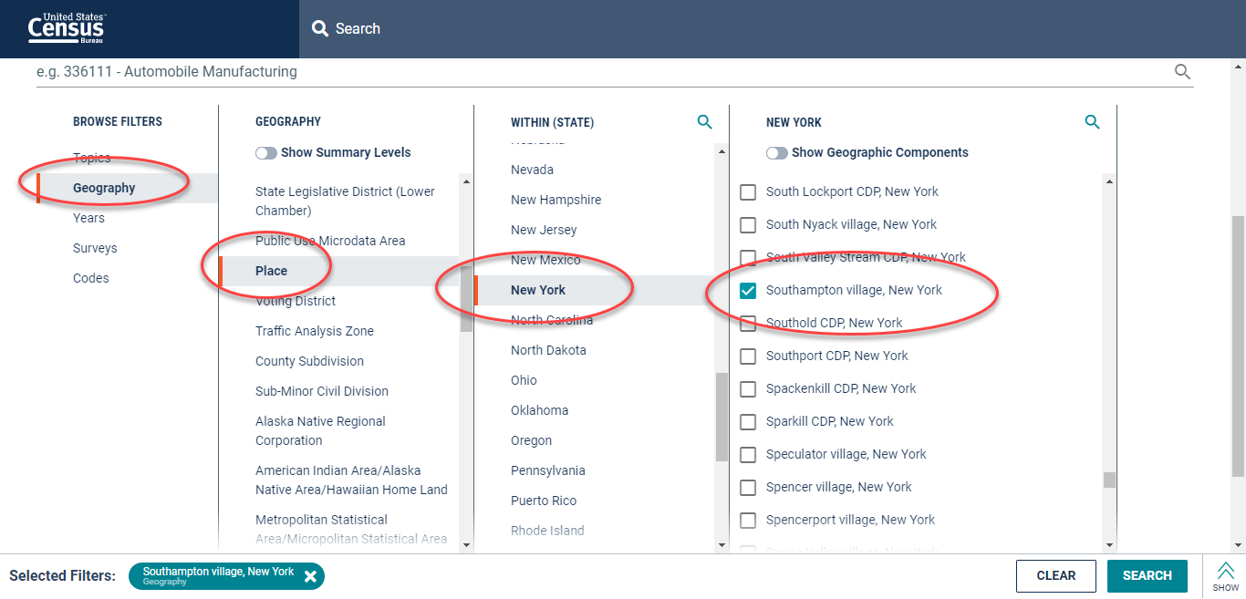**
* Select Geography>Tract>New York>Suffolk County, New York>**Census Tract 1908, Suffolk County, New York  
    
  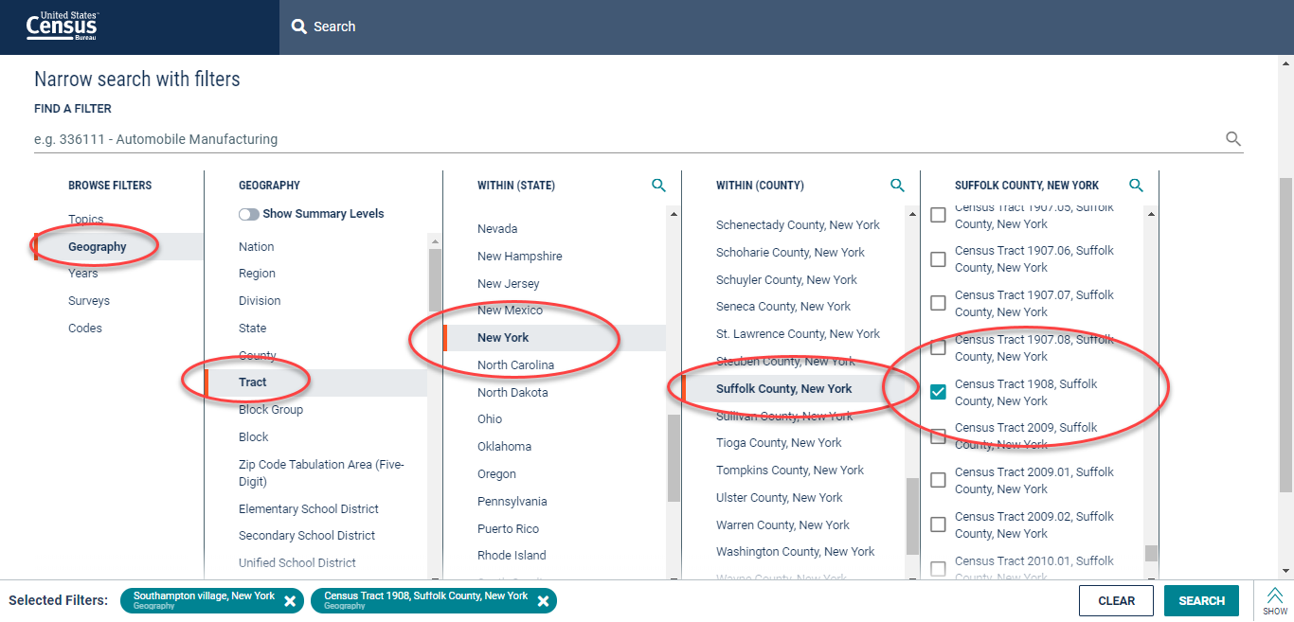**
* Select Geography>Block Group>New York>Suffolk County, New York>Census Tract 1908>**All block groups in census tract 1908  
    
  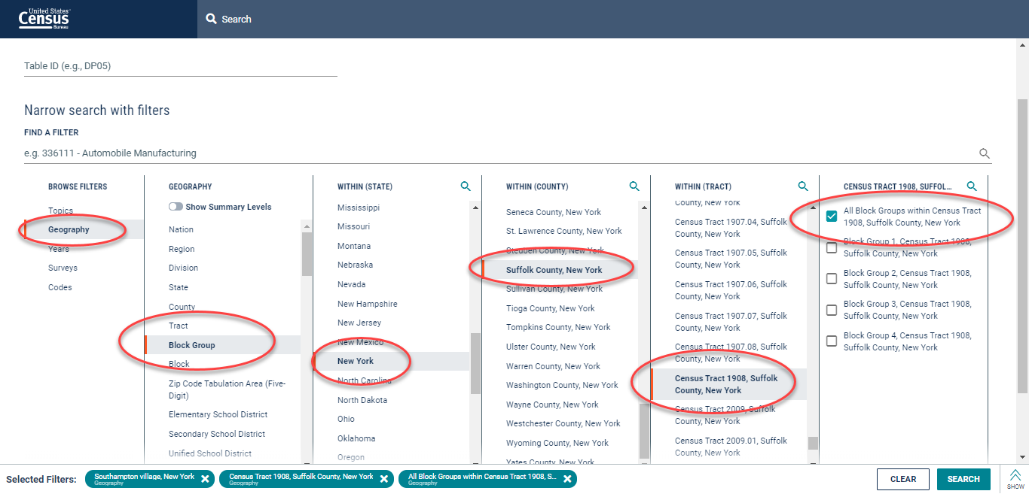**
* Click **Search** in the lower right
* Click **Tables** in the upper left
* View your table results:  
    
  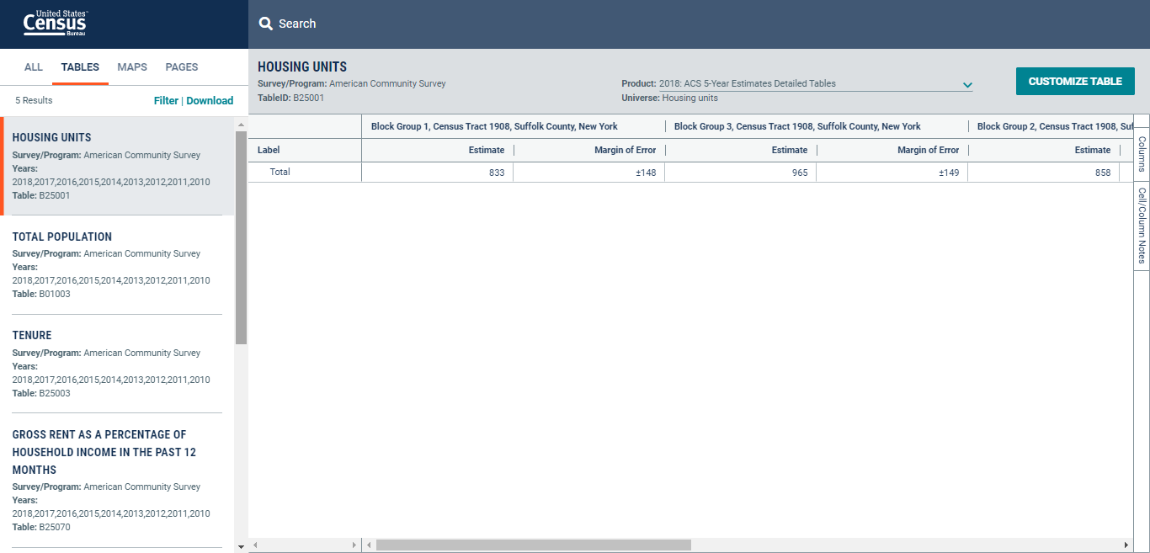

Census does not have data on population/residential density. They do have data on the number of total people/housing units. You can grab the land area data and calculate density on your own.

You can find land area by county in our Gazetteer files.  Go here: [https://www.census.gov/geographies/reference-files/time-series/geo/gazetteer-files.html](https://urldefense.proofpoint.com/v2/url?u=https-3A__www.census.gov_geographies_reference-2Dfiles_time-2Dseries_geo_gazetteer-2Dfiles.html&d=DwMFaQ&c=ckSw_QPOgiN5c7mkmGRjIUX5yYfoDM2_jKaJzviCxzI&r=pfIzrLyYynD_Lc_x3OVWBli6LDmsyrcrq8d6peKYQ7A&m=3Zoh1kM-VWvefp07TbQPdPYG9wF14q_FBelx_JRvu2A&s=vz_JAlqEVZMdJGT5nuLvp2adNrjRap09zNip5ySfEwc&e=)

ALAND is area for land in meters.  AWATER is area for water in meters.  ALAND_sqmi and AWATER_sqmi are the respective areas in square miles.