1. Select “User Functions” from the display. Bottom row of options, center button. (Figure 1)

**Figure 1**:

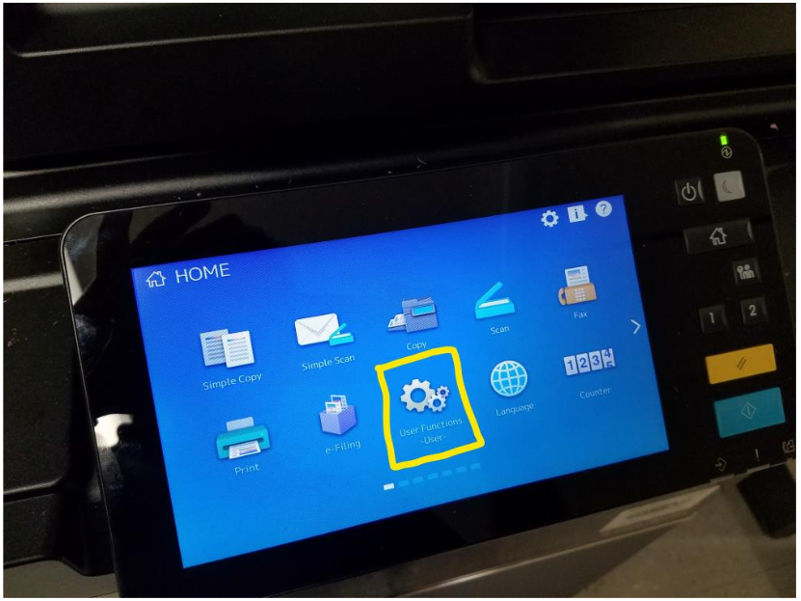

1. Next, Select “Address”. (Figure 2)

**Figure 2**:

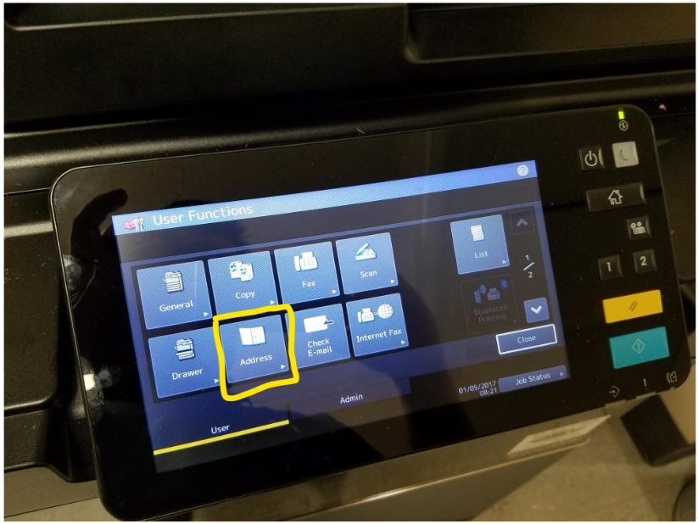

1. From the Address List, select an empty row, and choose “Entry”. (Figure 3)

**Figure 3**:

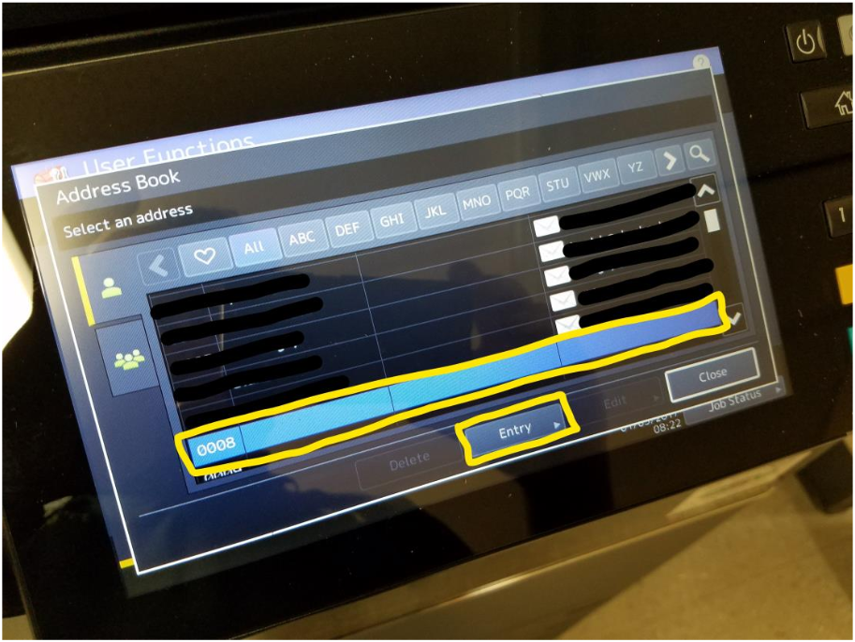

1. Fill out the following fields: First Name, Last Name, and E-Mail Address (must be @southamptontownny.gov address) and then select “OK” to save. (Figure 4)

**Figure 4**:

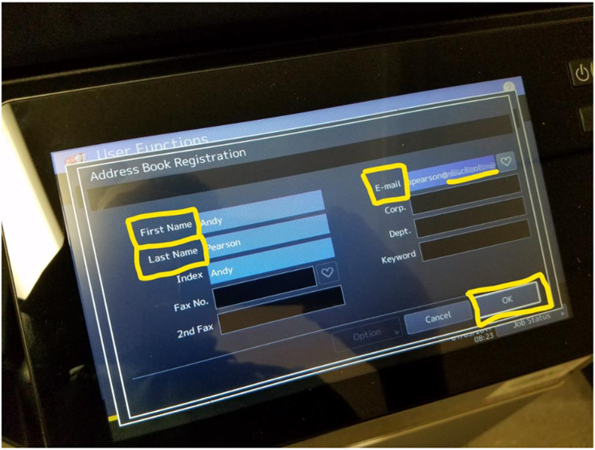

1. Your address will appear in the listing for “Scan to E-mail” for the copier you completed these steps on. Select “Close” to exit this menu. (Figure 5)

**Figure 5**:

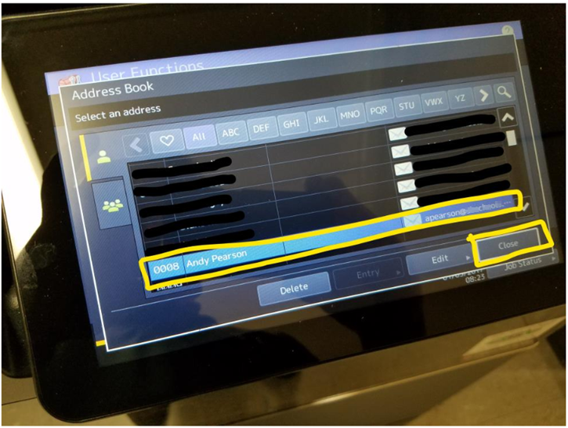

1. Finally, select “Close” on the “User Functions” menu to complete the registration process. (Figure 6)

**Figure 6**:

